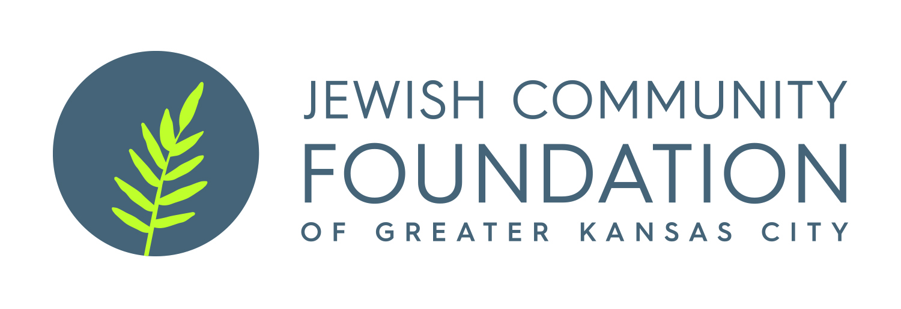
Frank Friedberg Fund Grant Application

Cover Sheet

Applicant Organization:___________________________________________________

Program Title:__________________________________________________________

Program Start Date: ___________________ Program End Date:_____________

Grant Amount Requested: $_____________ Total Program Budget:$ _________

Agency Budget $ ______________________

Grant summary, including description of program, need addressed and expected outcomes/benefits (please limit to space below):

Frank Friedberg Fund Grant Application

Please e-mail applications to Beatrice Fine at bfine@jcfkc.org AND Antoinette Wells at awells@jcfkc.org.

If you are applying to the Frank Friedberg Fund for the first time, a copy of your IRS tax-exempt letter stating that you are a 501(c)(3) organization is required.

- The following information is required:

A. Name and address of applying organization

B. Application contact person, title, email and phone number

C. Title of proposed program

- Description of program

- Describe specifically the activities of the program being proposed and its goals and objectives.

- What population will be served? How many will be served?

- What is the time period for the program?

- What is the location of the program?

- How will this program be marketed to its target population?

- Who will be responsible for administering the program, both volunteer and professional? What are their qualifications?

E. Describe the extent of the need for this program and how it came to your organization’s attention.

F. How will the Jewish community ultimately benefit from the implementation of this program?

G. Has this program been implemented before by your organization, by another organization in Kansas City or elsewhere? What were the results?

H. How does this program relate to the ongoing goals and activities of your organization?

- Financial Information

- What is the dollar amount requested for this program? What is the total percentage of this amount to the total cost of the program?

- What is the line item budget for this program? Include a complete revenue projection and complete detail by expense categories.

- What internal fiscal resources will your organization invest in the program?

- Describe the source, amount and status of other requests for funding.

- How will partial funding of this grant application impact the program’s implementation?

- Is this an on-going program? If yes, how does your organization plan to assume the costs in future years?

- Evaluation

- What are the expected short-term and long-term outcomes of this program?

- How will these outcomes be evaluated?

- Why should the Frank Friedberg Fund support this program?

- Please complete the Agency Budget and Program Budget form found here, under the Frank Friedberg Fund heading: https://www.jcfkc.org/grants-scholarships/grants. If you’d like to submit an internal budget form instead, please contact Beatrice Fine at 913-327-4618 or bfine@jcfkc.org.

For questions regarding your organization’s grant application please contact Beatrice Fine at bfine@jcfkc.org or 913-327-4618.

