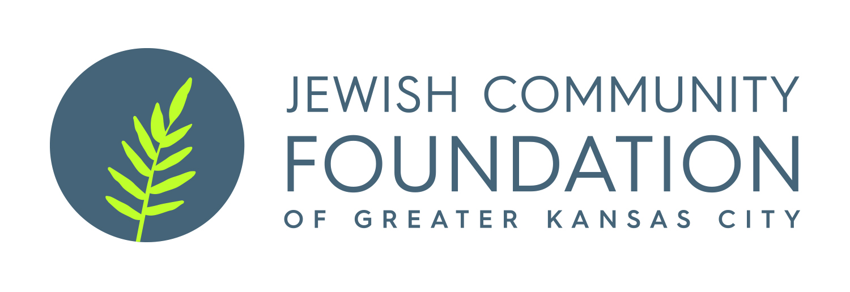
Jewish Art Fund
Grant Application

Programs should promote Jewish art and art education for all age groups.

Cover Sheet

Applicant Organization:___________________________________________________________________

Program Title: __________________________________________________________________________

Program Date (s):____________________________

Grant Amount Requested:_____________________ Total Program Budget:_____________________

Agency Budget: _____________________________

Grant summary, including description of program, goals, and expected outcomes/benefits (please limit to space below):

Jewish Art Fund Grant Application

Grant applications and cover sheets should be e-mailed to Beatrice Fine, at bfine@jcfkc.org AND Antoinette Wells at awells@jcfkc.org.

If you are applying to the Jewish Community Foundation for the first time, a copy of your IRS tax determination letter stating that you are a 501(c)(3) organization is required.

The following information is required. Letter/Number your responses to correspond with the letters/numbers below:

- Name and address of applying organization

B. Application contact person, title, email and phone number

C. Title of program

- Description of program

- Describe specifically the program being proposed and its goals and objectives. How do you see this program promoting arts education within the Jewish community or education about Judaic art?

2. What population will be served? How many do you expect to attend or participate?

3. What is the date of the program?

4. How will this program be marketed to its target population?

- Who will be responsible for administering the program, both volunteer and professional? What are their qualifications?

- Describe the extent of the need for this program and how it came to your organization’s attention.

F. How will the Jewish community ultimately benefit from the implementation of this program?

G. Has this program been implemented before by your organization, by another organization in Kansas City or elsewhere? What were the results?

H. How does this program relate to the ongoing goals and activities of your organization?

- Financial Information

- What is the dollar amount requested for this program? Of the total cost of the program, what percentage is this amount?

2. What is the line item budget for this program? Please include a complete revenue projection and complete detail by expense categories. Is this event a fundraiser?

3. What internal fiscal resources will your organization invest in the program?

- Describe the source, amount and status of other requests for funding.

- How will partial funding of this grant application impact the program’s implementation?

- Is this an on-going program? If yes, how does your organization plan to assume the costs in future years?

- Evaluation

- What are the expected short-term and long-term outcomes of this program?

- How will these outcomes be evaluated?

- Why should the Jewish Art Fund support this program?

- Please complete the Agency Budget and Program Budget form found here, under the Jewish Art Fund heading: https://www.jcfkc.org/grants-scholarships/grants. If you’d like to submit an internal budget form instead, please contact Beatrice Fine at 913-327-4618 or bfine@jcfkc.org.

