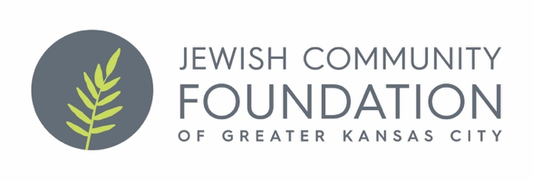
Katianne’s Sunshine Fund for the Benefit of Special Needs Programming
Application

This fund was created in memory of Katianne Bordy Tannenwald. The purpose of the fund is to enhance the lives of Jewish special needs individuals in Kansas City through group enrichment and fun programming. Just as Katianne brightened other people’s lives, this fund is meant to do the same.

The fund is not meant to be used to provide service to one individual or to defray existing program costs.

Please fill out the information below.

An agency budget, program budget, and current board list must accompany the application. Applications may be submitted for up to $1,000. Please submit the form to Antoinette Wells at awells@jcfkc.org and bfine@jcfkc.org. For questions regarding your organization’s grant application please contact Beatrice Fine at 913-327-4618 or bfine@jcfkc.org. Applications are due June 15 or if that falls on a weekend, the next business day.

Organization: ________________________________________________________

Program Name:__________________________________________________________________

Executive Director/and or Contact Person Information: ________________________

____________________________________________________________________

Grant Amount Requested: $_____________________

Total Program Budget: $_____________

Total Agency Budget: $______________

Projected Number of Individuals Served:

Program Description:

Please provide a one-page summary of your programming idea. How do you think it will enhance your offerings for special needs constituents?

