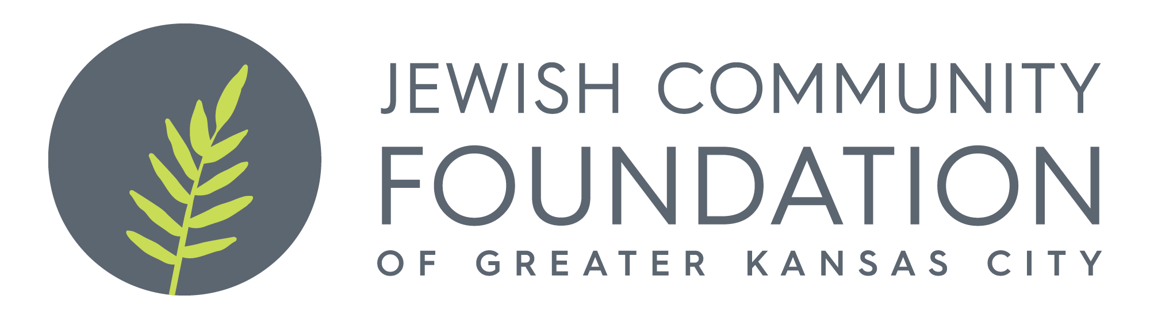
Flo Harris Foundation
Grant Application

Please fill out the information below.

An agency budget and program budget must accompany this application. Please submit the form to Antoinette Wells at awells@jcfkc.org. For questions regarding your organization’s grant application please contact Beatrice Fine at 913-327-4618 or bfine@jcfkc.org. Applications are due May 16, or if that falls on a weekend, the next business day.

Organization: ________________________________________________________

Program Name:________________________________________________________

Executive Director/and or Contact Person Information: ________________________

____________________________________________________________________

Grant Amount Requested: $_____________________
Total Program Budget: $___________.

Total Agency Budget: $______________

Projected Number of Individuals Served: Program Description: Please provide a one-page summary of your program design, goals, and expected outcomes/benefits and summary.

If you have received prior funding from this, please provide a narrative and financial summary of how the funds were used.

